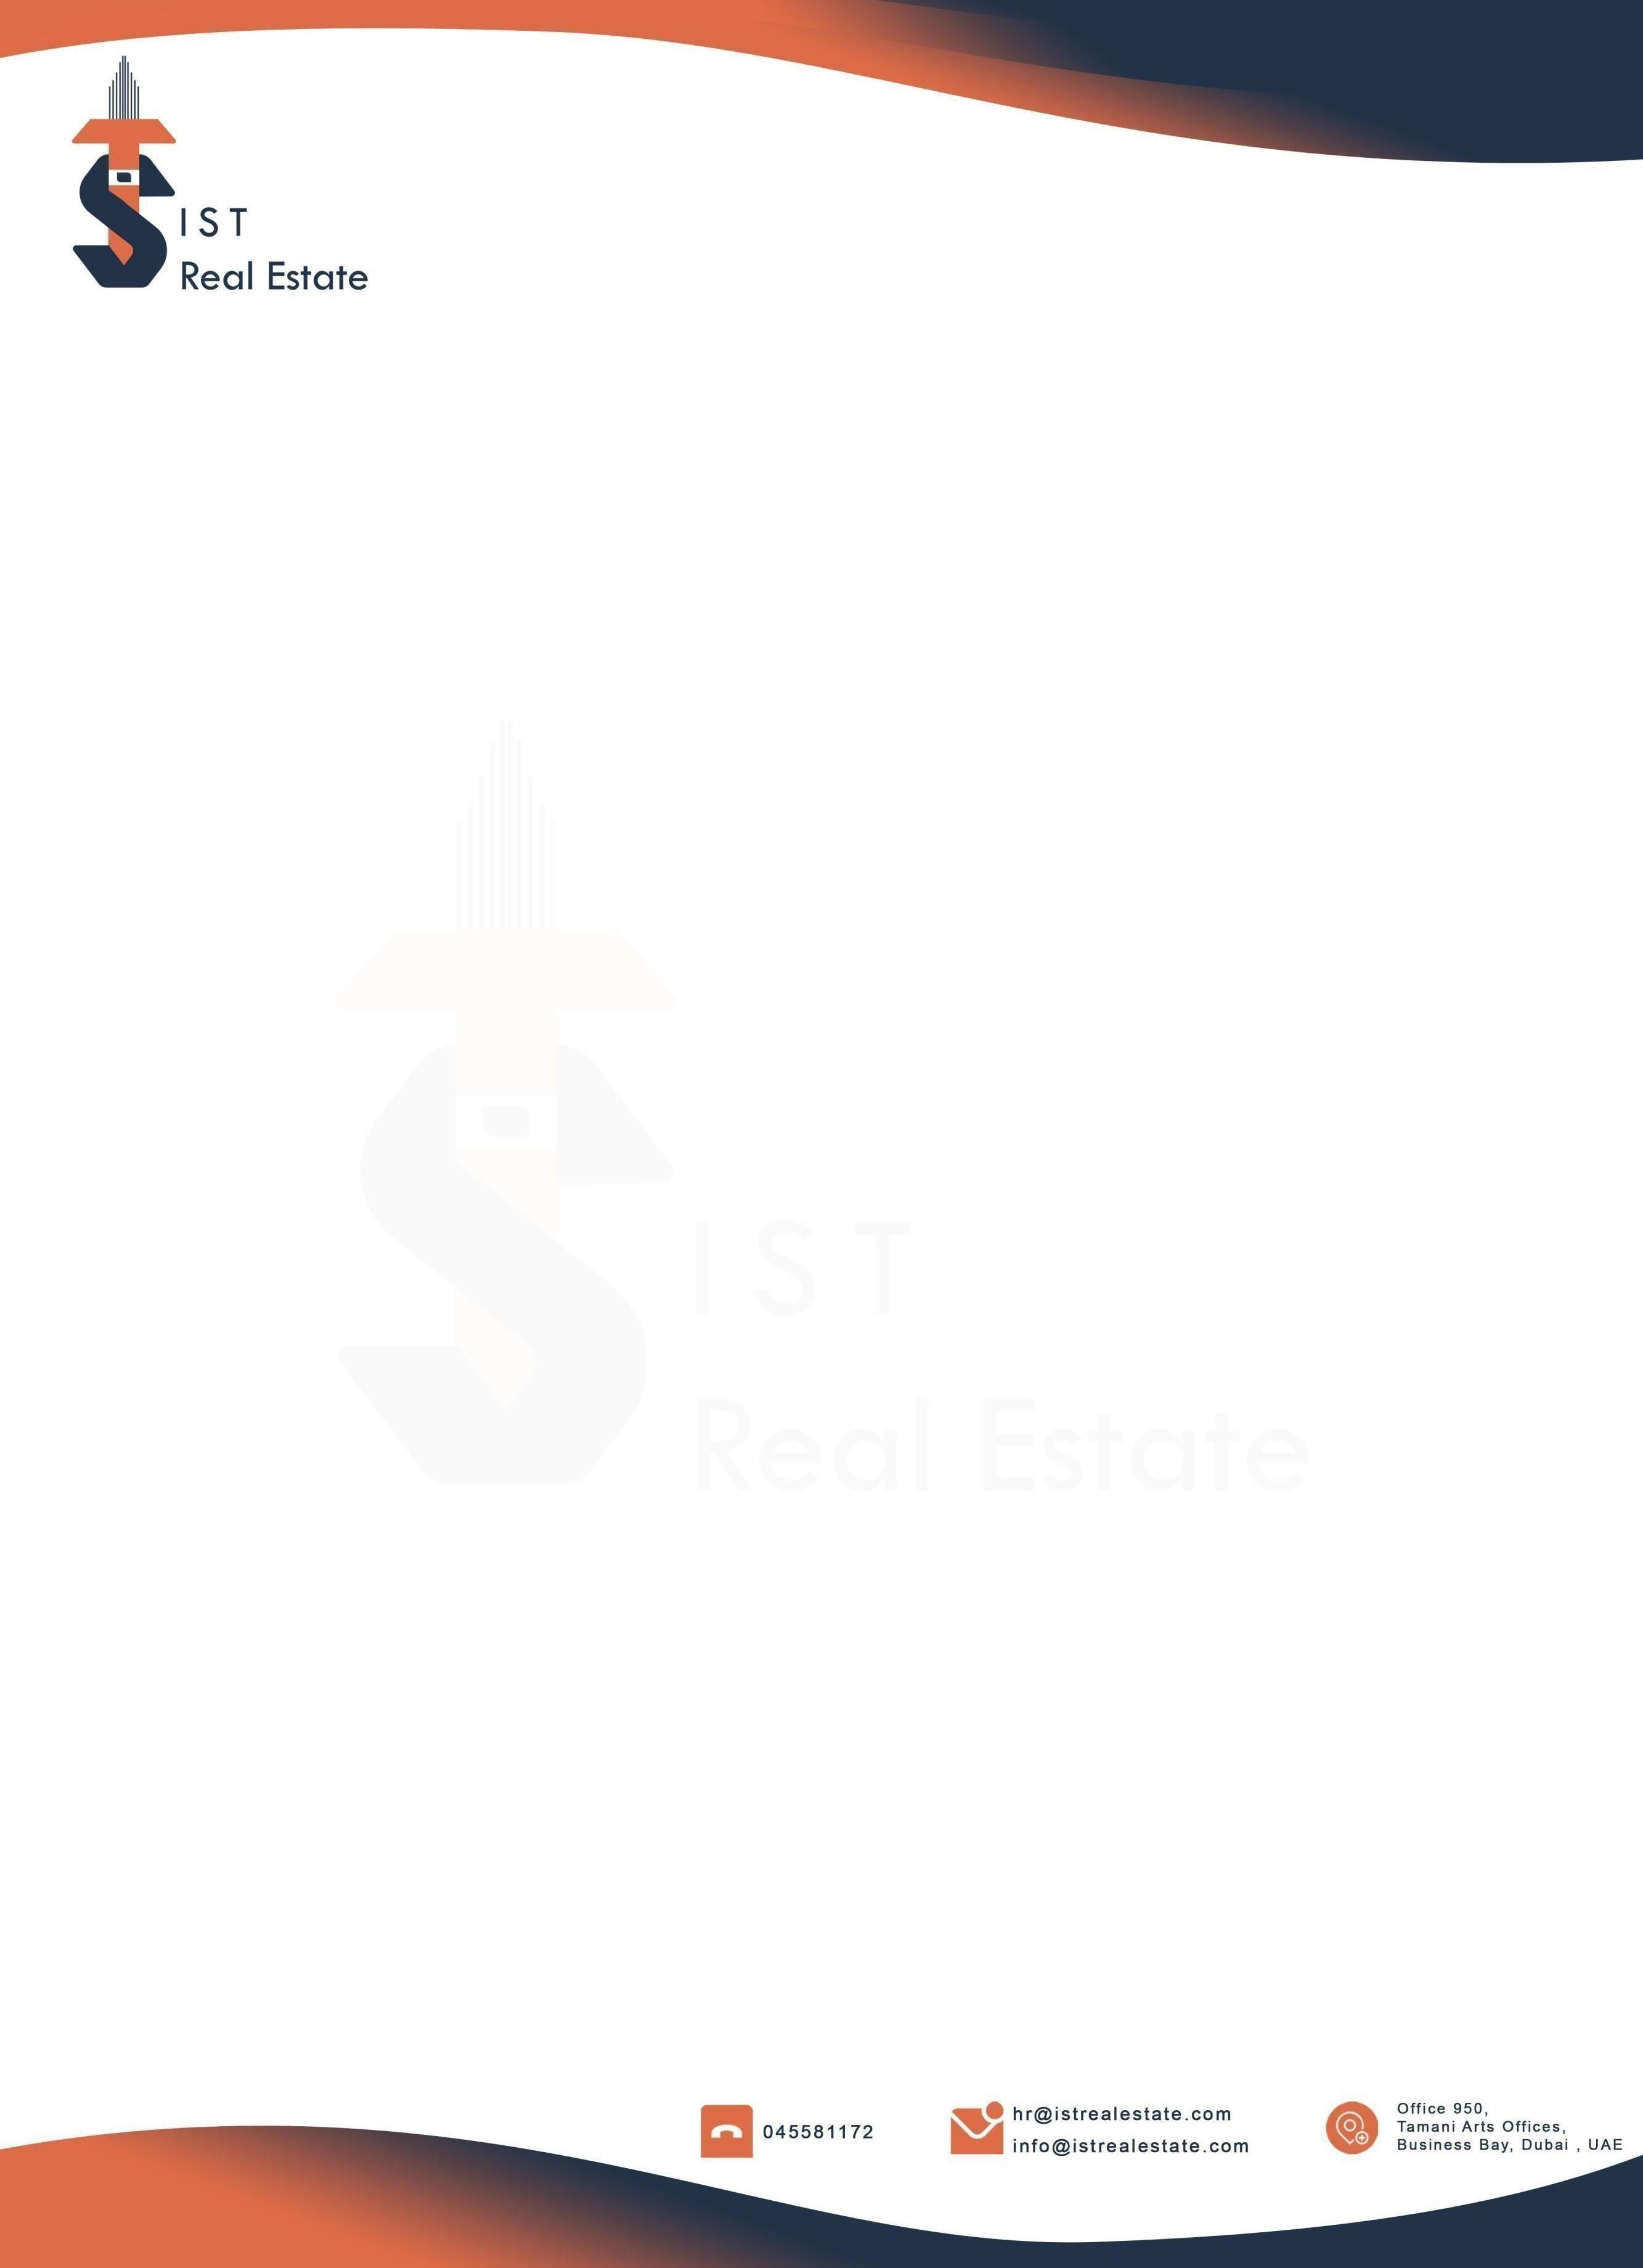

NAME : REDAB SADOUM
DEPARTMENT : SALES
DATE : 07 FEB 2026

OFFER OF EMPLOYMENT – SUBJECT TO CONTRACT

Dear Redab Sadoun,
We are pleased to offer you the position of Real Estate Agent at I S T Real Estate LLC. We were thoroughly impressed by your qualifications, experience, and interview performance, and we believe you will make a valuable contribution to our team.
The Terms and conditions of your employment will be as follows:
- Commission : 50% Commission for leads provided by the company.
60% Commission for Personal leads generated by the agent
- Probation Period : 6 Months.
- Working Hours : 10:00 AM to 7:00 PM, Monday to Friday
10:00 AM to 3:00 PM, Saturday
- Annual Leave : 30 Days as per UAE Labor Law
- Other Benefits : Employment Visa and Medical Insurance
- Anticipated Start Date : 07 FEB 2026

Acceptance of this offer, along with an email confirmation, is required, including your signature and the date to confirm your agreement with the proposed terms, policies, and HR Manual of the company. This offer is valid for a period of three working days from the date of issuance.

We are excited to have you onboard and look forward to working with you. Please feel free to contact us should you have any questions or wish to discuss any aspects of the above.

Yours Sincerely

Mohammed Shahbaaz Signature:
HR Specialist Date:

